D.A.v. public school,

Dehradun



Session:-2019-2020

Computer science project

**Std:-** 12th science

**Roll no:** 22

**Submitted to:** **submitted by:**

*mr.ujjawal bhattacharya VISHAL joshi*

*PROJECT BASED ON*

*STUDENT REPORT*

*CARD*

*MANAGEMENT*

*SYSTEM*

**CERTIFICATE**

ROLL NU:_____ EXAM NO:_____

This is to certify that **VISHAL JOSHI** student of 12th has successfully completed the research on the below mentoned project under the guidance of **Mr.UJJAWAL BHATTACHARYA** during the year of 2019-2020 in partial fulfilment of computer science practical examination conducted by D.A.V. PUBLIC SCHOOL, DEHRADUN.

_______________________________ __________________________

SIGNATURE OF EXTERNAL SIGNATURE OF

EXAMINER INTERNAL EXAMINER

INDEX

|  |  |  |
| --- | --- | --- |
| **SR.NO** | **CONTENT** | **PAGE NO.** |
| 1) | CERTFICATE OF EXCELLENCE |  |
| 2) | ACKNOWLEDGEMENT |  |
| 3) | INTRODUCTION |  |
| 4) | SOURCE  CODE |  |
| 5) | OUTPUT WINDOW |  |
| 6) | CONCLUSION |  |
| 7) | BIBLIOGRAPHY |  |

Acknowledgement

IN THE ACCOPLISHMENT OF THIS PROJECT SUCCESSFULLY, MANY PEOPLE HAVE BEST OWNED UPON ME THEIR BLESSINGS AND THE HEART PLEDGE SUPPORT, THIS TIME I AM UTILIZING TO THANK ALL THE PEOPLE WHO HAVE BEEN CONCERNED WITH THE PROJECT.

PRIMARILY I WOULD LIKE THANK GOD FOR BEING ABLE TO COMPLETE THIS PROJECT WITH SUCCESS. THEN I WOULD LIKE TO THANK MY PRINCIPAL **MRS.SARIKA MOHAN BEMBEY** AND MY COMPUTER TEACHER **MR,UJJAWAL BHATTACHARYA**WHOSE VALUABLE GUIDANCE HAS BEEN THE ONES THAT HELPED ME PATCH THIS PROJECT AND MAKE IT FULL PROOF SUCCESS, HIS SUGGESTIONS AND INSTRUCTIONS HAS SEVED AS THE MAJOR CONTRIBUTION TOWARDS THE COMPLETION OF THIS PROJECT.

THEN I WOULD LIKE TO THANK MY PARENTS WHO HAVE HELPED ME WITH THEIR VALUABLE SUGGESTIONS AND GUIDANCE HAS BEEN VERY HELPFUL IN VARIOUS PHASES OF THE COMPLETION OF THE PROJECT.

INTRODUCTION

Student report card system project in C++ is a simple console application built without the use of graphics. This project ‘Student Report Card’ helps in managing the record of students according to their roll no, name, marks in all ‘5’ subjects, etc. And tried to maintain all the possibility which may help the user to enter more record if he/she requires. Some of the features of the program are:

1)Create Student Report Card: This feature creates a new student record containing his marks.

2) Read all students report card record ( Class Record ): This feature helps us to see all records of student report card system project present in the binary file of the in C++ program.

3)Read specific student report card record: This feature is same as the one explained above, except it shows the progress report and releavant data related to a particular student.

4)Search student record: This feature help’s to search record of a single student from the bundle of data, on inputting the student roll number.

5)Delete student record: This feature deletes the record of a particular student , on inputting his/her roll number.

6) Exit Program: This feature helps the user to get out of the ‘Output Screen’.

HEADER FILES USED:

**1)#include<fstream.h>**

File streams **include** to member functions specillay designed to read and write binary data sequentially: write & read. The first one (write) is a member function of ostream (inherited by ofstream). And read is a member function of istream (inherited by **ifstream).** Objects of class **fstream** have both.

**2)#include<iomanip>**

The header **<iomanip>** is a part of the input/output library of the C++ Standard Library. It defines the manipulator functions resetiosflags(), setiosflags(), setbase(),setprecision, and **setw().** These functions maybe conveniently used by C++ programs to affect the state of iostream objects**. //Only setw() has been used in Project.**

**3)#include<conio>**

Stands for ‘Console input & output’. It contains the functions of console input and otput. This function is used to **clear output scrren. //used functions clrscr() & getch().**

**4)#include<stdio>**

Statement which tells the Compiler to Insert the contents of **stdio** at that particular place. **stdio.h** is the header file used for getting the input from the user(keboard) and the output result text to the monitor(screen).

**5>#include<stdlib>**

Is the header file of the general purpose standard library of C programming language which includes functions involving memory allocation, process control, conversions, and others. It is compatible with **C++** and is known as cstdlib in C++. The name **‘stdlib’** stands for ‘standard library’.

**Source code**

**//\*\*\*\*\*\*\*\*\*\*\*\*\*\*\*\*\*\*\*\*\*\*\*\*\*\*\*\*\*\*\*\*\*\*\*\*\*\*\*\*\*\*\*\*\*\*\*\*\*\*\*\*\*\*\*\*\*\*\*\*\*\*\***

**// HEADER FILE USED IN PROJECT**

**//\*\*\*\*\*\*\*\*\*\*\*\*\*\*\*\*\*\*\*\*\*\*\*\*\*\*\*\*\*\*\*\*\*\*\*\*\*\*\*\*\*\*\*\*\*\*\*\*\*\*\*\*\*\*\*\*\*\*\*\*\*\*\*\***

#include<conio.h>

#include<stdio.h>

#include<fstream.h>

#include<stdlib.h>

#include<iomanip.h>

**//\*\*\*\*\*\*\*\*\*\*\*\*\*\*\*\*\*\*\*\*\*\*\*\*\*\*\*\*\*\*\*\*\*\*\*\*\*\*\*\*\*\*\*\*\*\*\*\*\*\*\*\*\*\*\*\*\*\*\*\*\*\*\***

**// CLASS USED IN PROJECT**

**//\*\*\*\*\*\*\*\*\*\*\*\*\*\*\*\*\*\*\*\*\*\*\*\*\*\*\*\*\*\*\*\*\*\*\*\*\*\*\*\*\*\*\*\*\*\*\*\*\*\*\*\*\*\*\*\*\*\*\*\*\*\*\*\***

class student

{

int rollno;

char name[50];

int p_marks,c_marks,m_marks,e_marks,cs_marks;

float per;

char grade;

int std;

void calculate()

{

per=(p_marks+c_marks+m_marks+e_marks+cs_marks)/5.0;

if(per>=60)

grade='A';

else if(per>=50 && per<60)

grade='B';

else if(per>=33 && per<50)

grade='C';

else

grade='F';

}

public:

void getdata()

{

cout<<"\nEnter The roll number of student ";

cin>>rollno;

cout<<"\n\nEnter The Name of student(IN 10 'CHARACTERS') ";

gets(name);

cout<<"\nEnter The marks in physics out of 100 : ";

cin>>p_marks;

cout<<"\nEnter The marks in chemistry out of 100 : ";

cin>>c_marks;

cout<<"\nEnter The marks in maths out of 100 : ";

cin>>m_marks;

cout<<"\nEnter The marks in english out of 100 : ";

cin>>e_marks;

cout<<"\nEnter The marks in computer science out of 100 : ";

cin>>cs_marks;

calculate();

}

void showdata()

{

cout<<"\nRoll number of student : "<<rollno;

cout<<"\nName of student : "<<name;

cout<<"\nMarks in Physics : "<<p_marks;

cout<<"\nMarks in Chemistry : "<<c_marks;

cout<<"\nMarks in Maths : "<<m_marks;

cout<<"\nMarks in English : "<<e_marks;

cout<<"\nMarks in Computer Science :"<<cs_marks;

cout<<"\nPercentage of student is :"<<per;

cout<<"\nGrade of student is :"<<grade;

}

void show_tabular()

{

cout<<rollno<<setw(12)<<name<<setw(12)<<p_marks<<setw(3)<<c_marks<<setw(3)<<m_marks<<setw(3)<<e_marks<<setw(3)<<cs_marks<<setw(7)<<setprecision(3)<<per<<" "<<grade<<endl;

}

int retrollno()

{

return rollno;

}

}; //class ends here

**//\*\*\*\*\*\*\*\*\*\*\*\*\*\*\*\*\*\*\*\*\*\*\*\*\*\*\*\*\*\*\*\*\*\*\*\*\*\*\*\*\*\*\*\*\*\*\*\*\*\*\*\*\*\*\*\*\*\*\*\*\*\*\***

**// GLOBAL DECLARATION FOR STREAM OBJECT , OBJECT**

**//\*\*\*\*\*\*\*\*\*\*\*\*\*\*\*\*\*\*\*\*\*\*\*\*\*\*\*\*\*\*\*\*\*\*\*\*\*\*\*\*\*\*\*\*\*\*\*\*\*\*\*\*\*\*\*\*\*\*\*\*\*\*\*\***

fstream fp;

student st;

**//\*\*\*\*\*\*\*\*\*\*\*\*\*\*\*\*\*\*\*\*\*\*\*\*\*\*\*\*\*\*\*\*\*\*\*\*\*\*\*\*\*\*\*\*\*\*\*\*\*\*\*\*\*\*\*\*\*\*\*\*\*\*\***

**// FUNCTION TO WRITE IN FILE**

**//\*\*\*\*\*\*\*\*\*\*\*\*\*\*\*\*\*\*\*\*\*\*\*\*\*\*\*\*\*\*\*\*\*\*\*\*\*\*\*\*\*\*\*\*\*\*\*\*\*\*\*\*\*\*\*\*\*\*\*\*\*\*\*\***

void write_student()

{

fp.open("student.dat",ios::out|ios::app);

st.getdata();

fp.write((char*)&st,sizeof(student));

fp.close();

cout<<"\n\nstudent record Has Been Created ";

getch();

}

**//\*\*\*\*\*\*\*\*\*\*\*\*\*\*\*\*\*\*\*\*\*\*\*\*\*\*\*\*\*\*\*\*\*\*\*\*\*\*\*\*\*\*\*\*\*\*\*\*\*\*\*\*\*\*\*\*\*\*\*\*\*\*\***

**// FUNCTION TO READ SPECIFIC RECORD FROM FILE**

**//\*\*\*\*\*\*\*\*\*\*\*\*\*\*\*\*\*\*\*\*\*\*\*\*\*\*\*\*\*\*\*\*\*\*\*\*\*\*\*\*\*\*\*\*\*\*\*\*\*\*\*\*\*\*\*\*\*\*\*\*\*\*\*\***

void display_sp(int n)

{

int flag=0;

fp.open("student.dat",ios::in);

while(fp.read((char*)&st,sizeof(student)))

{

if(st.retrollno()==n)

{

clrscr();

st.showdata();

flag=1;

}

}

fp.close();

if(flag==0)

cout<<"\n\nrecord not exist";

getch();

}

**//\*\*\*\*\*\*\*\*\*\*\*\*\*\*\*\*\*\*\*\*\*\*\*\*\*\*\*\*\*\*\*\*\*\*\*\*\*\*\*\*\*\*\*\*\*\*\*\*\*\*\*\*\*\*\*\*\*\*\*\***

**// FUNCTION TO DELETE RECORD OF FILE**

**//\*\*\*\*\*\*\*\*\*\*\*\*\*\*\*\*\*\*\*\*\*\*\*\*\*\*\*\*\*\*\*\*\*\*\*\*\*\*\*\*\*\*\*\*\*\*\*\*\*\*\*\*\*\*\*\*\*\*\*\*\*\*\*\***

void delete_student()

{

int no;

clrscr();

cout<<"\n\n\n\tDelete Record";

cout<<"\n\nPlease Enter The roll number of student You Want To Delete";

cin>>no;

fp.open("student.dat",ios::in|ios::out);

fstream fp2;

fp2.open("Temp.dat",ios::out);

fp.seekg(0,ios::beg);

while(fp.read((char*)&st,sizeof(student)))

{

if(st.retrollno()!=no)

{

fp2.write((char*)&st,sizeof(student));

}

}

fp2.close();

fp.close();

remove("student.dat");

rename("Temp.dat","student.dat");

cout<<"\n\n\tRecord Deleted ..";

getch();

}

**//\*\*\*\*\*\*\*\*\*\*\*\*\*\*\*\*\*\*\*\*\*\*\*\*\*\*\*\*\*\*\*\*\*\*\*\*\*\*\*\*\*\*\*\*\*\*\*\*\*\*\*\*\*\*\*\*\*\*\*\*\*\*\***

**// FUNCTION TO DISPLAY ALL STUDENT GRADE RECORD**

**//\*\*\*\*\*\*\*\*\*\*\*\*\*\*\*\*\*\*\*\*\*\*\*\*\*\*\*\*\*\*\*\*\*\*\*\*\*\*\*\*\*\*\*\*\*\*\*\*\*\*\*\*\*\*\*\*\*\*\*\*\*\*\*\***

void class_result()

{

clrscr();

fp.open("student.dat",ios::in);

if(!fp)

{

cout<<"ERROR!!! FILE COULD NOT BE OPEN\n\n\n Go To Entry Menu to create File";

cout<<"\n\n\n Program is closing ....";

getch();

exit(0);

}

cout<<"\n\n\t\tALL STUDENTS RESULT \n\n";

cout<<"====================================================\n";

cout<<"Roll No. Name P C M E CS %age Grade\n";

cout<<"====================================================\n";

while(fp.read((char*)&st,sizeof(student)))

{

st.show_tabular();

}

fp.close();

getch();

}

**//\*\*\*\*\*\*\*\*\*\*\*\*\*\*\*\*\*\*\*\*\*\*\*\*\*\*\*\*\*\*\*\*\*\*\*\*\*\*\*\*\*\*\*\*\*\*\*\*\*\*\*\*\*\*\*\*\*\*\*\*\*\*\***

**// FUNCTION TO DISPLAY RESULT MENU**

**//\*\*\*\*\*\*\*\*\*\*\*\*\*\*\*\*\*\*\*\*\*\*\*\*\*\*\*\*\*\*\*\*\*\*\*\*\*\*\*\*\*\*\*\*\*\*\*\*\*\*\*\*\*\*\*\*\*\*\*\*\*\*\*\***

void result()

{

int ans,rno;

char ch;

clrscr();

cout<<"\n\n\nRESULT MENU";

cout<<"\n\n\n1. Class Result\n\n2. Student Report Card\n\n3.Back to Main Menu";

cout<<"\n\n\nEnter Choice (1/2)? \n";

cin>>ans;

switch(ans)

{

case 1 :

class_result();

break;

case 2 :

{

do

{

clrscr();

char ans;

cout<<"\n\nEnter Roll Number Of Student : ";

cin>>rno;

display_sp(rno);

cout<<"\n\nDo you want to See More Result (y/n)?";

cin>>ans;

}

while(ans=='y'||ans=='Y');

break;

}

case 3:

break;

default:

cout<<"INVALID OPTION";

}

}

**//\*\*\*\*\*\*\*\*\*\*\*\*\*\*\*\*\*\*\*\*\*\*\*\*\*\*\*\*\*\*\*\*\*\*\*\*\*\*\*\*\*\*\*\*\*\*\*\*\*\*\*\*\*\*\*\*\*\*\*\*\*\*\***

**// INTRODUCTION FUNCTION**

**//\*\*\*\*\*\*\*\*\*\*\*\*\*\*\*\*\*\*\*\*\*\*\*\*\*\*\*\*\*\*\*\*\*\*\*\*\*\*\*\*\*\*\*\*\*\*\*\*\*\*\*\*\*\*\*\*\*\*\*\*\*\*\*\***

void intro()

{

clrscr();

gotoxy(35,11);

cout<<"STUDENT";

gotoxy(33,14);

cout<<"REPORT CARD";

gotoxy(35,17);

cout<<"PROJECT";

cout<<"\n\nMADE BY :SAURABH KAPRAWAN";

cout<<"\n\nMADE BY :VISHAL JOSHI ";

getch();

}

**//\*\*\*\*\*\*\*\*\*\*\*\*\*\*\*\*\*\*\*\*\*\*\*\*\*\*\*\*\*\*\*\*\*\*\*\*\*\*\*\*\*\*\*\*\*\*\*\*\*\*\*\*\*\*\*\*\*\*\*\*\*\*\***

**// ENTRY / EDIT MENU FUNCTION**

**//\*\*\*\*\*\*\*\*\*\*\*\*\*\*\*\*\*\*\*\*\*\*\*\*\*\*\*\*\*\*\*\*\*\*\*\*\*\*\*\*\*\*\*\*\*\*\*\*\*\*\*\*\*\*\*\*\*\*\*\*\*\*\*\***

void entry_menu()

{

clrscr();

char ch2;

cout<<"\n\n\n\tENTRY MENU";

cout<<"\n\n\t1.CREATE STUDENT RECORD";

cout<<"\n\n\t2.SEARCH STUDENT RECORD ";

cout<<"\n\n\t3.DELETE STUDENT RECORD";

cout<<"\n\n\t4.BACK TO MAIN MENU";

cin>>ch2;

switch(ch2)

{

case '1':

clrscr();

write_student();

break;

case '2':

int num;

clrscr();

cout<<"\n\n\tPlease Enter The roll number ";

cin>>num;

display_sp(num);

break;

case '3':

delete_student();

break;

case '4':

break;

default:

clrscr();

entry_menu();

}

}

**//\*\*\*\*\*\*\*\*\*\*\*\*\*\*\*\*\*\*\*\*\*\*\*\*\*\*\*\*\*\*\*\*\*\*\*\*\*\*\*\*\*\*\*\*\*\*\*\*\*\*\*\*\*\*\*\*\*\*\*\*\*\*\***

**// THE MAIN FUNCTION OF PROGRAM**

**//\*\*\*\*\*\*\*\*\*\*\*\*\*\*\*\*\*\*\*\*\*\*\*\*\*\*\*\*\*\*\*\*\*\*\*\*\*\*\*\*\*\*\*\*\*\*\*\*\*\*\*\*\*\*\*\*\*\*\*\*\*\*\*\***

void main()

{

char ch;

intro();

do

{

clrscr();

cout<<"\nENTER YOUR CHOICE";

cout<<"\n01. RESULT MENU";

cout<<"\n02. ENTRY/EDIT MENU";

cout<<"\n03. EXIT\n";

cin>>ch;

switch(ch)

{

case '1':

clrscr();

result();

break;

case '2':

entry_menu();

break;

case '3':

exit(0);

break;

default :

cout<<"INVALID OPTION";

}

}

while(ch!='3');

}

**//\*\*\*\*\*\*\*\*\*\*\*\*\*\*\*\*\*\*\*\*\*\*\*\*\*\*\*\*\*\*\*\*\*\*\*\*\*\*\*\*\*\*\*\*\*\*\*\*\*\*\*\*\*\*\*\*\*\*\*\*\*\*\***

**// END OF PROJECT**

**//\*\*\*\*\*\*\*\*\*\*\*\*\*\*\*\*\*\*\*\*\*\*\*\*\*\*\*\*\*\*\*\*\*\*\*\*\*\*\*\*\*\*\*\*\*\*\*\*\*\*\*\*\*\*\*\*\*\*\*\*\*\*\***

OUTPUT WINDOWS OF THE ABOVE SOURCE CODE

* IntroDUCTION menu

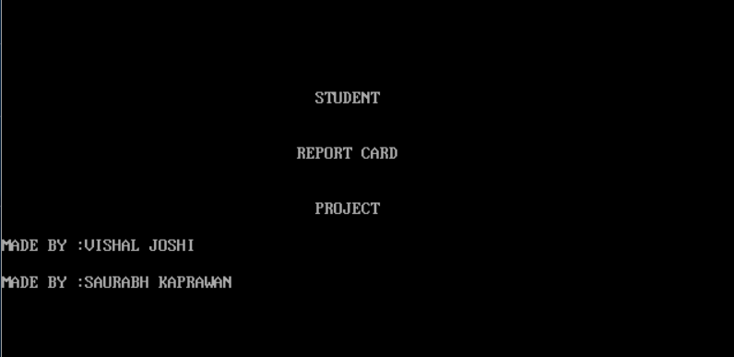

* Main MENU

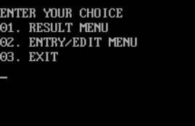

* Result menu

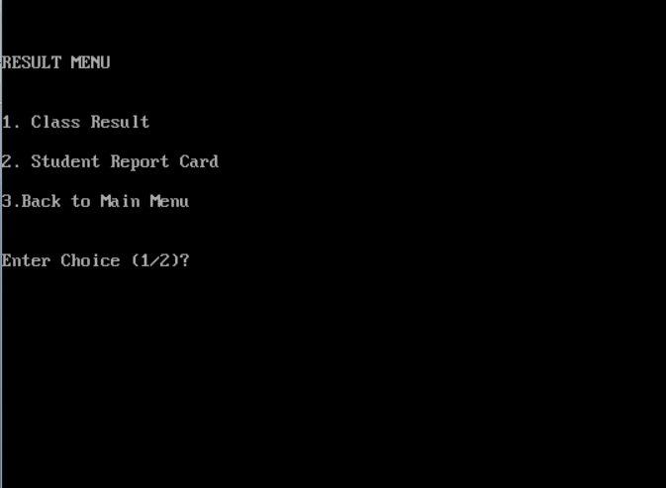

* UNDER RESULT MENU

1) class result

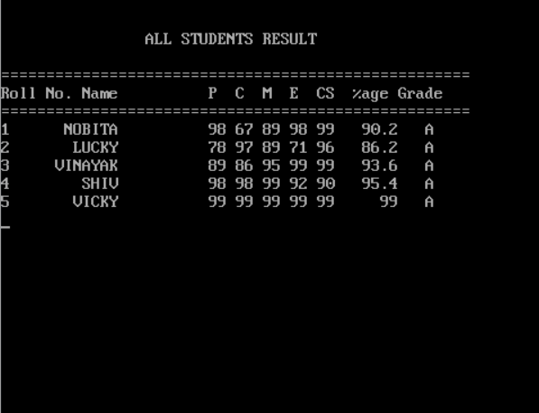

2) student report card

C:\Users\VISHAL JOSHI\Pictures\comp7.PNG

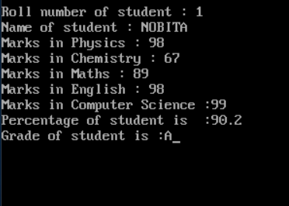**On entering 1**

**3)back to main menu**

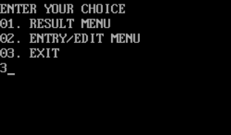

**ON INPUTTING 3**

**MAIN MENU APPEARS**



* **Entry / edit menu**

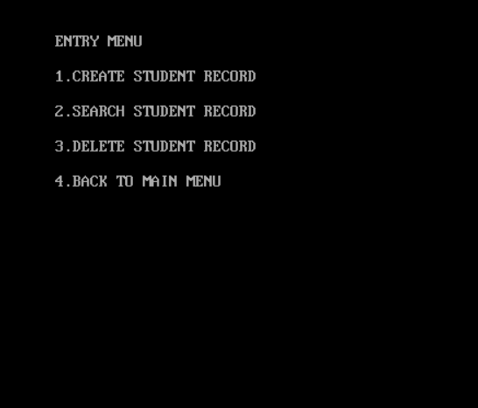

* Under entry / edit menu

1)create student record

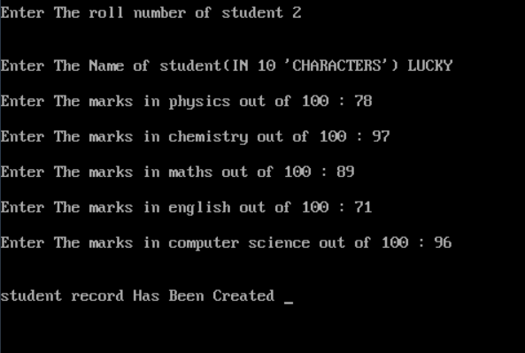

2)search student record

C:\Users\VISHAL JOSHI\Pictures\comp7.PNG

ON ENTERING ROLL NO (IF RECORD EXIST ,THEN ONLY)

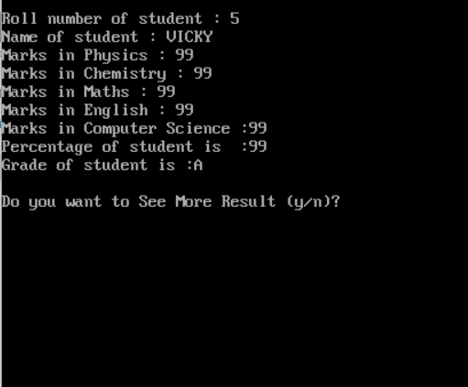3)delete student record

C:\Users\VISHAL JOSHI\Pictures\comp7.PNG

ON ENTERING ROLL NUMBER (OR ANY ) EXIST IN RECORD roll number entered =>2

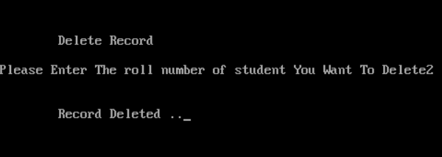4)exiting entry / edit menu

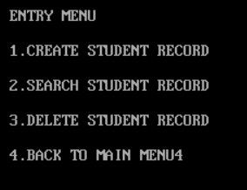

On PRESSING 4 MAIN MENU APPEARS



* Exiting program

ON PREESING 3 blue C++ program screen appears

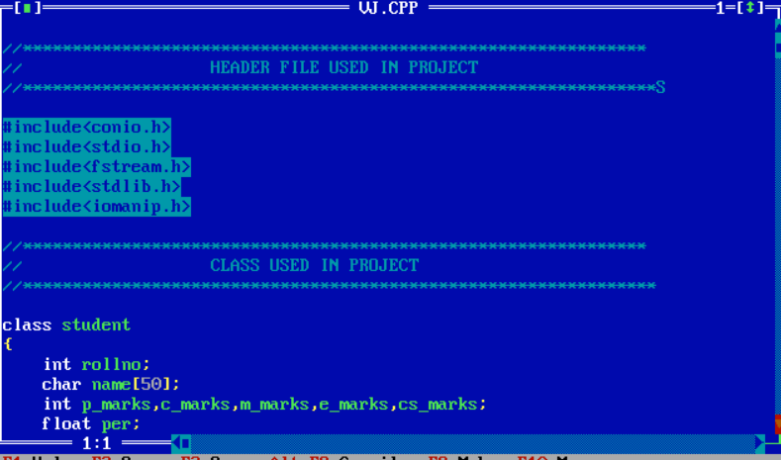

CONCLUSION

This software has its advantage and disadvantages but it can surely help with the record storage system. We don’t have to worry about the misplacing of record which is a great clash while storing the record on separate files.

Limitations

* Does not support mouse.
* If some string is gives as input i.e. place where integer should have been input, the program crashes and dat file gets spoiled.
* This project can only work on a **C++ Software.**

**BIBLIOGRAPHY**

**Sumitra arrora class 12**

**Website :**

[**http://www.google.co.in**](http://www.google.co.in)

[**http://www.wikipedia.com**](http://www.wikipedia.com)

**Thank**

**YOU**